Questão-aula 1
1.
Monómio | Coeficiente ou parte numérica | Parte literal | Grau
$$x^{3}yz$$ | 1 | $$x^{3}yz$$ | 5
$$3xy^{2}$$ | $$3$$ | $$xy^{2}$$ | 3
$$-\frac{1}{2}x^{3}y$$ | $$-\frac{1}{2}$$ | $$x^{3}y$$ | 4
2.1. $x^{4}y^{2}z$; grau 7 2.2. $6x^{3}y$; grau 4 2.3. $-24x^{6}yz^{2}$; grau 9
Questão-aula 2
1. $\frac{xy^{2}}{2}$ , $3xy^{2}$ e $-2xy^{2}$ ; $3x$ e $x$
2.1. ${-\left(-1\right)}^{2}×\frac{2}{3}=-\frac{2}{3}$ 2.2. $3×\left(-1\right)×{\left(\frac{2}{3}\right)}^{2}=-\frac{4}{3}$ 2.3. $-2{\left(-1×\frac{2}{3}\right)}^{2}=-2×\frac{4}{9}=-\frac{8}{9}$
Questão-aula 3
1.1. $3x+5+12x-6=15x-1$
1.2. $3xy+5y-2xy-6=xy+5y-6$
1.3. $\frac{3}{2}x^{2}+5x-x^{2}=\frac{3}{2}x^{2}-\frac{2}{2}x^{2}+5x=\frac{1}{2}x^{2}+5x$
1.4. $\frac{1}{2}-\left(y-2\right)-6\left(x+y\right)=\frac{1}{2}-y+2-6x-6y=-6x-7y+\frac{5}{2}$
1.5. $\frac{3}{2}-\frac{1}{2}\left(x-\frac{2}{3}\right)=\frac{3}{2}-\frac{1}{2}x+\frac{2}{6}=-\frac{1}{2}x+\frac{11}{6}$
1.6. $1-\frac{1-x^{2}}{2}+4\left(x+\frac{x^{2}}{3}\right)=1-\frac{1}{2}+\frac{x^{2}}{2}+4x+\frac{4x^{2}}{3}$ $=\frac{3x^{2}+8x^{2}}{6}+4x+\frac{1}{2}=\frac{11}{6}x^{2}+4x+\frac{1}{2}$
2.1. $P=5×\left[3\left(-x+\frac{1}{5}\right)+1\right]=5\left(-3x+\frac{3}{5}+1\right)=-15x+3+5=-15x+8$
2.2. $P=\left[\left(2x-3y\right)+\left(x-2y\right)\right]×4=\left(2x-3y+x-2y\right)×4=\left(3x-5y\right)×4=12x-20y$
Questão-aula 4
$$3x^{2}-3xy+ ∎∎∎∎=-9xy$$ |  | - $-\frac{5}{2}+a{xy}^{2}$
$$a{xy}^{2}-(∎∎∎∎)=\frac{5}{2}$$ |  | - $-6xy-3x^{2}$
$$xy+2\left(∎∎∎∎\right)=2a+3xy$$ |  | - $-\frac{2}{15}x^{2}+\frac{2}{5}xy$
$$\frac{x^{2}}{3}-xy=-\frac{5}{2}\left(∎∎∎∎\right)$$ |  | - $xy+a$
Questão-aula 5
1.1. $-3x\left(x-1\right)={-3x}^{2}+3x$
1.2. $-2xy\left(y-x\right)={-2xy}^{2}+2x^{2}y$
1.3. ${\left(\frac{1}{2}x^{3}\right)}^{3}xy=\frac{1}{8}x^{9}xy=\frac{1}{8}x^{10}y$
1.4. $\left(3x-y^{2}\right)\left(-xy\right)=-3x^{2}y+xy^{3}=xy^{3}-3x^{2}y$
1.5. $\frac{1}{2}xyz\left(1-3x^{2}\right)=\frac{1}{2}xyz-\frac{3}{2}x^{3}yz=-\frac{3}{2}x^{3}yz+\frac{1}{2}xyz$
1.6. ${\left(\frac{x^{2}}{2}\right)}^{3}\left(-6xy\right)=\left(\frac{x^{6}}{8}\right)\left(-6xy\right)=-\frac{3}{4}x^{7}y$
2.1. ${\left(xy+3xy\right)}^{2}-{\left(xy\right)}^{2}={\left(4xy\right)}^{2}-{\left(xy\right)}^{2}=16x^{2}y^{2}-x^{2}y^{2}=15x^{2}y^{2}$
2.2. $\frac{\left(\frac{1}{5}x^{3}+3\right)\left(1-x\right)}{2}=\frac{\frac{1}{5}x^{3}-\frac{1}{5}x^{4}+3-3x}{2}=-\frac{1}{10}x^{4}+\frac{1}{10}x^{3}-\frac{3}{2}x+\frac{3}{2}$
Questão-aula 6
1.
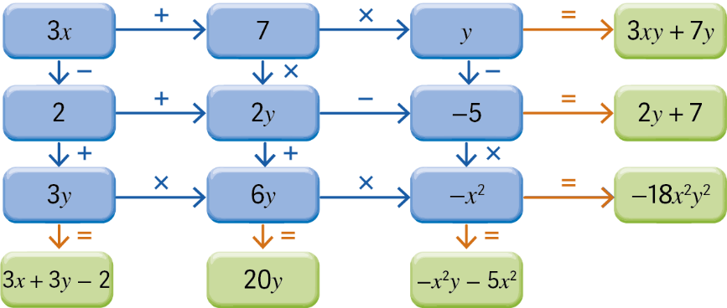
Questão-aula 7
1.1. $x-y=2\left(x-3y\right)⇔x-y=2x-6y⇔-y+6y=2x-x⇔5y=x⇔y=\frac{x}{5}$
1.2. $1-\frac{1}{3}\left(-\frac{3}{2}-x\right)=2y⇔1+\frac{1}{2}+\frac{x}{3}=2y⇔6+3+2x=12y⇔2x=12y-9⇔x=6y-\frac{9}{2}$
1.3. $\frac{2-y}{3}-\frac{-1-x}{2}=0⇔4-2y+3+3x=0⇔-2y=-3x-7⇔y=\frac{3}{2}x+\frac{7}{2}$
1.4. $\frac{1}{3}\left(6-y\right)-2\left(3-x\right)=7x⇔\frac{6}{3}-\frac{y}{3}-6+2x=7x⇔6-y-18+6x=21x⇔-15x=y+12$
$⇔x=-\frac{1}{15}y-\frac{12}{15} ⇔x=-\frac{1}{15}y-\frac{4}{5}$
2.
$$3x^{2}=-9xy$$ |  | - $\left(0 , 1\right)$
$$x-\frac{y}{2}=-xy$$ |  | - $\left(-3 , 1\right)$
$$xy^{2}-2xy=0$$ |  | - $\left(\frac{1}{4}, 1\right)$
$$y-2=-x-y$$ |  | - $\left( 2 , 0\right)$
Questão-aula 8
1.1. $2x+y=20,5$ 1.2. $2y=10x$
1.3. $\left(x+y\right)×0,7=35$ 1.4. $3y+2x=y+5x$
Questão-aula 9
1. $\left\{\begin{aligned}-3-\left(-1\right)=-2 \\ -3×3+2×\left(-1\right)=-11\end{aligned}⇔\left\{\begin{aligned}-2=-2 \\ -9-2=-11\end{aligned}⇔\left\{\begin{aligned}-2=-2 \\ -11=-11\end{aligned}\right.\right.\right.$
Logo, o par ordenado (3, –1) é solução do sistema.
2.1. $\left\{\begin{aligned}x-2y=1 \\ x+4=y\end{aligned}⇔\left\{\begin{aligned}x-2\left(x+4\right)=1 \\ x+4=y \end{aligned}⇔\right.\right.\left\{\begin{aligned}x-2x-8=1 \\ x+4=y \end{aligned}⇔\left\{\begin{aligned}x=-9 \\ -9+4=y\end{aligned}⇔\left\{\begin{aligned}x=-9 \\ y=-5\end{aligned}\right.\right.\right.$
$S = \{(-9, -5)\}$
2.2. $\left\{\begin{aligned}x-4=2\left(y+1\right) \\ x-2y=y \end{aligned}⇔\left\{\begin{aligned}x-4=2y+2 \\ x=3y \end{aligned}⇔\left\{\begin{aligned}3y-4=2y+2 \\ x=3y \end{aligned}\right.⇔\left\{\begin{aligned}y=6 \\ x=3×6\end{aligned}\right.\right.\right.⇔\left\{\begin{aligned}y=6 \\ x=18\end{aligned}\right.$
$S = \{(18, 6)\}$
Questão-aula 10
1.1. $r_{1} ↔ h$ ; $r_{2} ↔ p$ ; $r_{3} ↔ q$ ; $r_{4} ↔ g$ e $r_{5} ↔ f$
1.2. $\left\{\begin{aligned}y=-x+1 \\ y=2x-2\end{aligned}\right.$
1.3. $\left\{\begin{aligned}y=2x+3 \\ y=-3x+6\end{aligned}⇔\left\{\begin{aligned}y=2x+3 \\ 2x+3=-3x+6\end{aligned}⇔\right.\right.\left\{\begin{aligned}y=2x+3_ \\ 5x=3 \end{aligned}\right.⇔\left\{\begin{aligned}y=2×\frac{3}{5}+3 \\ x=\frac{3}{5} \end{aligned}\right.⇔\left\{\begin{aligned}y=\frac{6}{5}+3 \\ x=\frac{3}{5} \end{aligned}\right.⇔\left\{\begin{aligned}y=\frac{21}{5} \\ x=\frac{3}{5}\end{aligned}\right.$
$S=\left\{\left(\frac{3}{5}, \frac{21}{5}\right)\right\}$
Questão-aula 11
1. $\left\{\begin{aligned}2-\frac{x-1}{2}-2y=\frac{1}{2} \\ x+2\left(-1+2y\right)=1\end{aligned}\right.⇔\left\{\begin{aligned}4-x+1-4y=1 \\ x-2+4y=1 \end{aligned}⇔\left\{\begin{aligned}-x-4y=-4 \\ x+4y=3 \end{aligned}⇔\left\{\begin{aligned}-\left(3-4y\right)-4y=-4 \\ x=3-4y \end{aligned}⇔\right.\right.\right.$
$$⇔\left\{\begin{aligned}-3+4y-4y=-4 \\ x=3-4y \end{aligned}⇔\left\{\begin{aligned}0y=-1 \\ x=3-4y\end{aligned}\right.\right.$$
$S= ∅$ ; Sistema impossível
2.1. $\left\{\begin{aligned}x+y=0 \\ x+0y=2\end{aligned}⇔\right.\left\{\begin{aligned}2+y=0 \\ x=2\end{aligned}⇔\left\{\begin{aligned}y=-2 \\ x=2\end{aligned}\right.\right.$
$S=\left\{\left(2, -2\right)\right\}$ ; Sistema possível determinado
2.2. $\left\{\begin{aligned}x+y=1 \\ x+y=2\end{aligned}⇔\left\{\begin{aligned}x=1-y \\ 1-y+y=2\end{aligned}⇔\left\{\begin{aligned}x=1-y \\ 0y=1\end{aligned}\right.\right.\right.$
$S= ∅$ ; Sistema impossível
2.3. $\left\{\begin{aligned}2x+y=-1 \\ x-y=2 \end{aligned}⇔\left\{\begin{aligned}4+2y+y=-1 \\ x=2+y \end{aligned}⇔\left\{\begin{aligned}3y=-5 \\ x=2+y \end{aligned}⇔\left\{\begin{aligned}y=-\frac{5}{3} \\ x=2-\frac{5}{3}\end{aligned}⇔\left\{\begin{aligned}y=-\frac{5}{3} \\ x=\frac{1}{3} \end{aligned}\right.\right.\right.\right.\right.$
$S=\left\{\left(\frac{1}{3},-\frac{5}{3}\right)\right\}$ ; Sistema possível determinado

Questão-aula 12
1. $\left\{\begin{aligned}2\left(x+y\right)=28 \\ x-3y=-6 \end{aligned}\right.$
2. Sejam $x$ o número de moedas do saco com mais moedas e $y$ o número de moedas do saco com menos moedas.
$$\left\{\begin{aligned}x+y=200 \\ \frac{1}{4}x=y+5\end{aligned}\right.⇔\left\{\begin{aligned}x=200-y \\ x=4y+20\end{aligned}\right.⇔\left\{\begin{aligned}4y+20=200-y \\ x=4y+20 \end{aligned}\right.⇔\left\{\begin{aligned}5y=180 \\ x=4y+20\end{aligned}\right.⇔\left\{\begin{aligned}y=36 \\ x=164\end{aligned}\right.$$
A Mafalda colocou 164 moedas num dos sacos e 36 no outro.
Miniteste 1
1. (C) 2. (B) 3. (D) 4. (A)
Miniteste 2
1. (B) 2. (D) 3. (D) 4. (C)
Miniteste 3
1. (C) 2. (A) 3. (D) 4. (C) 5. (D)
Miniteste 4
1. (D) 2. (B) 3. (A) 4. (D)
Miniteste 5
1. (C) 2. (A) 3. (B)
Miniteste 6
1. (C) 2. (D) 3. (B)

Teste de Avaliação
1. (B) 2. (D) 3. (A)
4. (D) 5. (D) 6. (C)
7.1. $P=2x+y+x+3=3x+y+3$ e $A=x^{2}+3x$
7.2. $P=2\left(3x+4\right)+2\left(x^{2}-3\right)=6x+8+2x^{2}-6=2x^{2}+6x+2$ e $A=3x^{3}+{4x}^{2}-9x-12$
8.1. $3x+2y=6⇔2y=-3x+6⇔y=-\frac{3}{2}x+3$
8.2. Por exemplo: $(2, 0)$ e $(4, -3)$.
8.3.
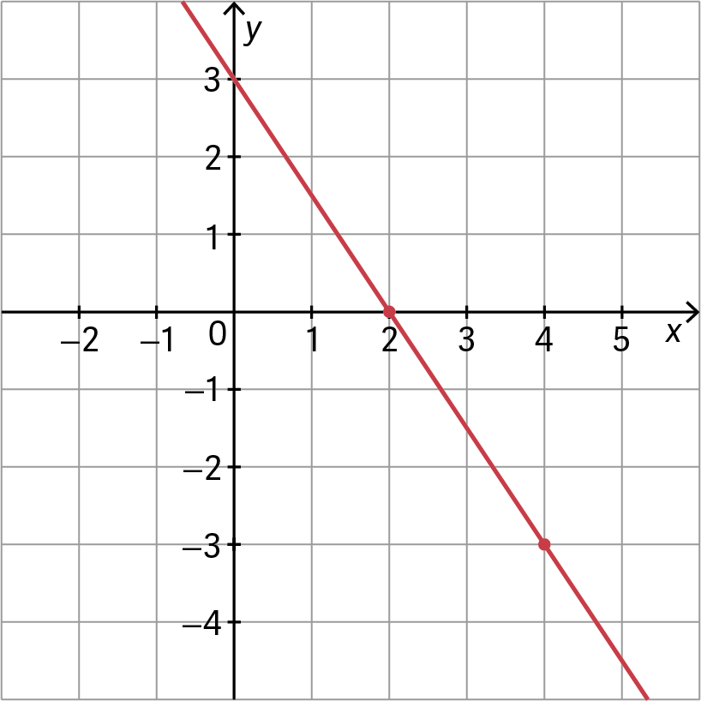

9.1. $\left\{\begin{aligned}3×2+6=-4×\left(-3\right) \\ 2-\left(-3+1\right)=2×2\end{aligned}⇔\left\{\begin{aligned}12=12 \\ 4=4\end{aligned}\right.\right.$
$\left(2, -3\right)$ é solução do sistema
9.2. $\left\{\begin{aligned}3x+6=-4y \\ x-\left(y+1\right)=2x\end{aligned}\right.⇔\left\{\begin{aligned}3x+4y=-6 \\ x-y-1=2x\end{aligned}\right.⇔\left\{\begin{aligned}3x+4\left(-x-1\right)=-6 \\ y=-x-1 \end{aligned}\right.$
$⇔\left\{\begin{aligned}3x-4x-4=-6 \\ y=-x-1 \end{aligned}⇔\left\{\begin{aligned}-x=-2 \\ y=-x-1\end{aligned}⇔\left\{\begin{aligned}x=2 \\ y=-3\end{aligned}\right.\right.\right. S=\left\{\left(2,-3\right)\right\}$
10.1. declive: $\frac{2-\left(-1\right)}{1-0}=3$ e $b=-1$ , logo $y=3x-1$ .
10.2. $\left\{\begin{aligned}y=3x-1 \\ ax+2-2y=0\end{aligned}⇔\left\{\begin{aligned}y=3x-1 \\ y=\frac{a}{2}x+1\end{aligned}\right.\right.$ $\frac{a}{2}=3⇔a=6$
O sistema é impossível para $a=6$ .
11.1. $\left\{\begin{aligned}x+y=75 \\ 2x+4y=200\end{aligned}\right.$
11.2. $\left\{\begin{aligned}x=75-y \\ 2\left(75-y\right)+4y=200\end{aligned}⇔\left\{\begin{aligned}x=75-y \\ 150-2y+4y=200\end{aligned}⇔\left\{\begin{aligned}x=75-y \\ y=\frac{50}{2} \end{aligned}⇔\left\{\begin{aligned}x=50 \\ y=25\end{aligned}\right.\right.\right.\right.$
O Sr. Campos tem 50 galinhas e 25 coelhos.

Ficha de desenvolvimento
1.
$$2x\left(x-3\right)$$ |  |  | $$4x^{2}-9$$
$$\left(2x-3\right)\left(2x+3\right)$$ |  |  | $$4x^{2}-12x+9$$
$${\left(2x-3\right)}^{2}$$ |  |  | $$2x^{2}-12x+18$$
$$2{\left(x-3\right)}^{2}$$ |  |  | $$2x^{2}-6x$$
2. $V_{prisma}=A_{base}×altura=\left(\frac{6x}{2}×3\right)\left(3x+2\right)=9x\left(3x+2\right)=27x^{2}+18x$
$V_{pirâmide}=\frac{1}{3}A_{base}×altura=\frac{1}{3}\left(x+3\right)×x×\left(2x-1\right)=\left(\frac{x^{2}}{3}+x\right)\left(2x-1\right)$
$$=\frac{2}{3}x^{3}-\frac{x^{2}}{3}+2x^{2}-x=\frac{2}{3}x^{3}+\frac{5}{3}x^{2}-x$$
3. $\frac{x+7}{2}+\frac{x}{3}+14+2\left(x+7\right)=\left(5x+x+2\right)×2⇔\frac{x+7}{2}+\frac{x}{3}+14+2x+14=12x+4$
$⇔3x+21+2x+84+12x+84=72x+24$
$$⇔-55x=-165⇔x=3$$
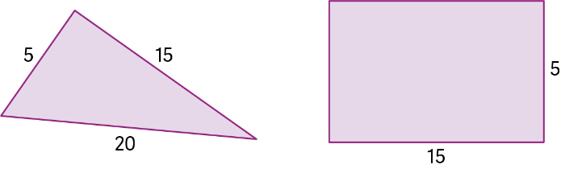
4.1. $t=6×12+\frac{3}{2}×9=72+\frac{27}{2}=85,5$
O tempo de prova foi 1 hora, 25 minutos e 30 segundos.
4.2. $t=6x+\frac{3}{2}y⇔6x=t-\frac{3}{2}y⇔x=\frac{t}{6}-\frac{y}{4}$
1 h 45 min corresponde a 105 minutos
$x=\frac{105}{6}-\frac{15}{4}=\frac{55}{4}=13,75 km$

5.1. $\left\{\begin{aligned}x+2y=5 \\ 2\left(x-1\right)=-\left(1+y\right)\end{aligned}⇔\left\{\begin{aligned}y=-\frac{1}{2}x+\frac{5}{2} \\ 2x-2=-1-y\end{aligned}⇔\right.\right.\left\{\begin{aligned}y=-\frac{1}{2}x+\frac{5}{2} \\ y=-2x+1\end{aligned}\right.$
5.2.
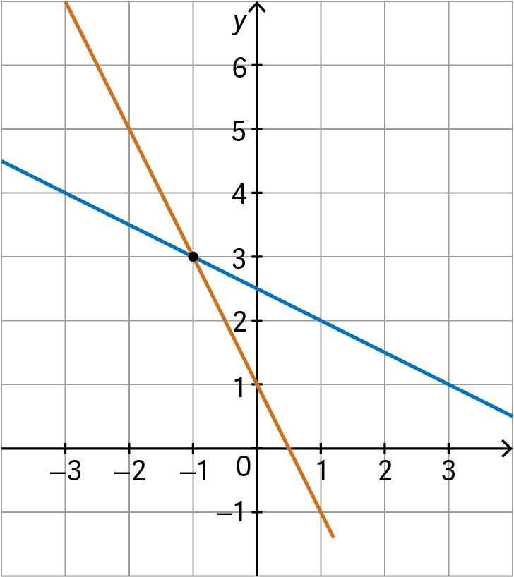
Ponto de interseção: $(-1 , 3)$
5.3. $\left\{\begin{aligned}y=-\frac{1}{2}x+\frac{5}{2} \\ -\frac{1}{2}x+\frac{5}{2}=-2x+1\end{aligned}⇔\left\{\begin{aligned}y=-\frac{1}{2}x+\frac{5}{2} \\ -x+5=-4x+2\end{aligned}⇔\left\{\begin{aligned}y=-\frac{1}{2}x+\frac{5}{2} \\ 3x=-3 \end{aligned}\right.\right.⇔\right.\left\{\begin{aligned}y=-\frac{1}{2}×\left(-1\right)+\frac{5}{2} \\ x=-1 \end{aligned}⇔\left\{\begin{aligned}y=3 \\ x=-1\end{aligned}\right.\right.$
$S=\left\{\left(-1, 3\right)\right\}$
6. $\left\{\begin{aligned}ax-y=5 \\ ay-x=4\end{aligned}⇔\left\{\begin{aligned}y=ax-5 \\ y=\frac{1}{a}x+\frac{4}{a}\end{aligned}\right.\right.$
Logo: $a=\frac{1}{a}⇔a^{2}=1⇔a=1 ∨ a=-1$
Se $a=1$ , $\frac{4}{a}=4$ e se $a=-1$ , $\frac{4}{a}=-4$ .
Portanto, o sistema é impossível para $a=1$ ou $a=-1$ .
7. $\left\{\begin{aligned}10x+15y=225 \\ x=y+5 \end{aligned}⇔\left\{\begin{aligned}10(y+5)+15y=225 \\ x=y+5 \end{aligned}⇔\left\{\begin{aligned}10y+15y+50=225 \\ x=y+5 \end{aligned}⇔\left\{\begin{aligned}y=7 \\ x=12\end{aligned}\right.\right.\right.\right.$
Foram 12 sócios e 7 não-sócios, no total 19 amigos.

